Leonardo AI: Transforming Visual Creativity
Subha Hassan

Introduction
Leonardo AI is a powerful AI tool used to generate high-quality images and visual content from text prompts. It is widely used for creating digital art, marketing visuals, game assets, and realistic images. This AI is useful for designers, marketers, and content creators who need fast and creative visual outputs. You would need this AI to produce professional-level graphics without advanced design skills or expensive software.

Prompt
Input Prompt Given:
“A futuristic Dhaka city at night, neon lights, cyberpunk style, ultra realistic, 4K resolution, highly detailed.”
Optional Inputs Used:
- Style: Cyberpunk
- Resolution: 4K
- Lighting: Neon / Night
- Detail Level: High
- Rendering Mode: Realistic

Output
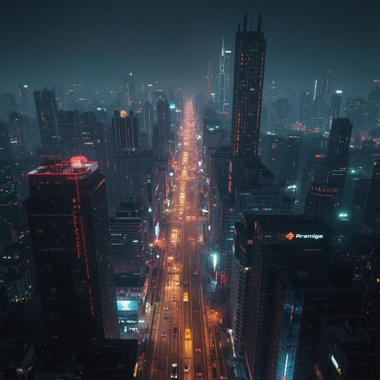

Describe Your Output
The generated image showed a futuristic version of Dhaka with glowing neon lights and advanced buildings. The details were sharp, and the lighting effects created a cinematic atmosphere. The cyberpunk theme was clearly visible and visually appealing. Overall, the output looked professional and suitable for digital marketing or creative projects.

Prompt Engineering
To improve the output quality, the prompt can be refined in the following ways:
- Use more descriptive keywords (e.g., “crowded streets, flying vehicles”).
- Add camera angles (e.g., aerial view, wide-angle shot).
- Specify color palette (blue neon, purple glow, etc.).
- Include reference artists or styles for better artistic direction.
- Adjust lighting effects (cinematic lighting, HDR, shadows).
- Define aspect ratio (1:1 for Instagram, 16:9 for YouTube thumbnails).
- Add environment details (rain, fog, reflections).
- Use negative prompts (avoid blur, distortion, low quality).

Conclusion
Leonardo AI is one of the most advanced AI image generators available today. Compared to tools like Midjourney or DALL·E, Leonardo AI offers more control and customization options. It performs especially well in generating detailed and realistic visuals. However, Midjourney may still produce more artistic outputs in some cases. Leonardo AI is particularly strong for marketing, branding, and game design, making it a highly valuable tool in professional contexts.

*I used ChatGPT for writing*

